Postman Register Result

HttpMethod: POST

Route: api/Account/Register

Description: Register account

URI Parameters: None

Body Parameters:

* email
* password
* confirmpassword

HttpResponseStatusCode: 400 Bad Request

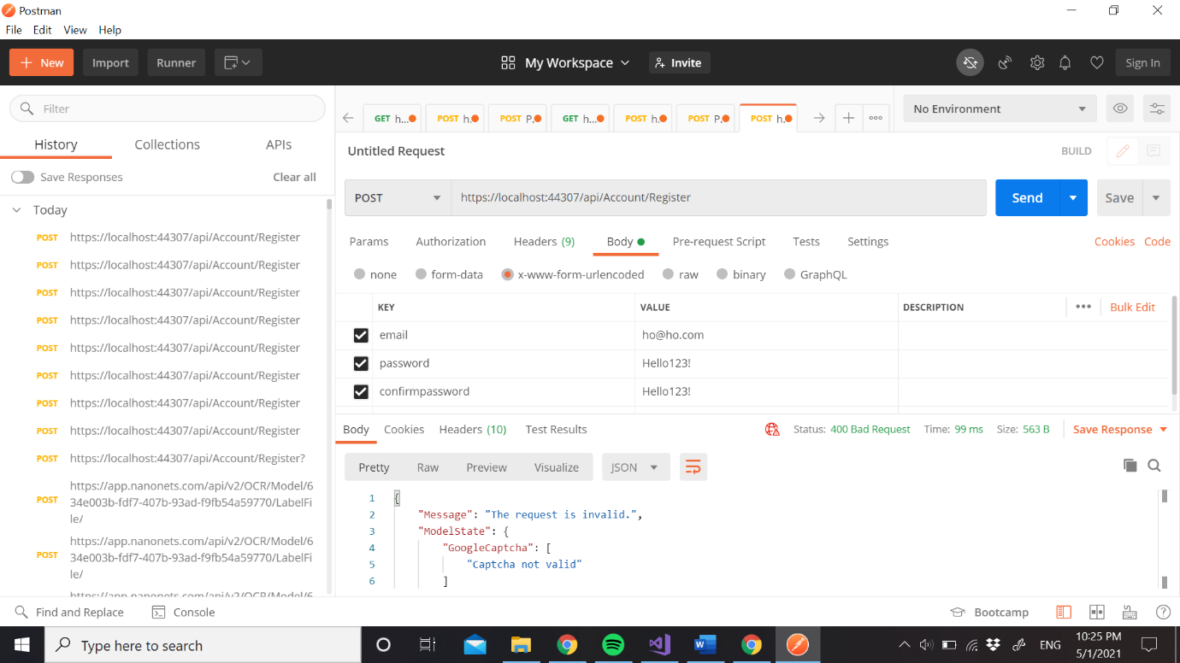

ReCaptcha Verify API

HttpMethod: POST

Route: https://www.google.com/recaptcha/api/siteverify

Description: Register account

URI Parameters: None

Body Parameters:

* secret
* response

HttpResponseStatusCode: 200 Ok